HW3

R12521601 詹承諺

HW3-1:

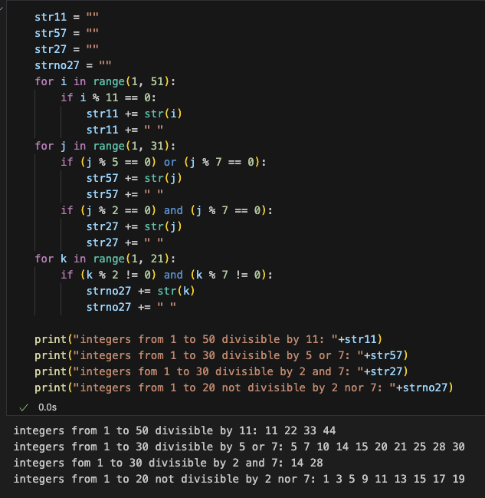

HW3-2:













HW3-3:













Simplex method:

The Simplex method is a method to find an optimal solution for linear programs. To get this solution, we start at a vertex and move from another improving the value of the objective function.

HW3-4:

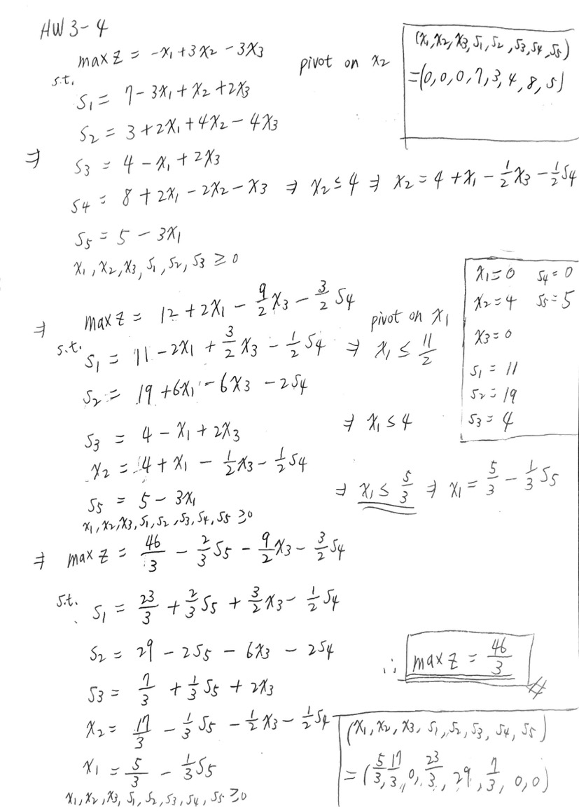

HW3-5

